Day 46 musical time machine

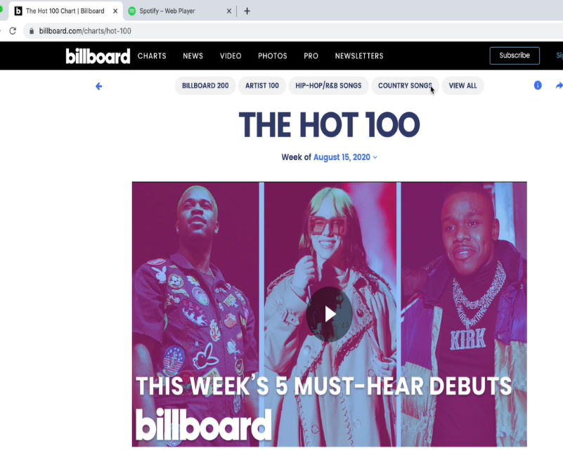

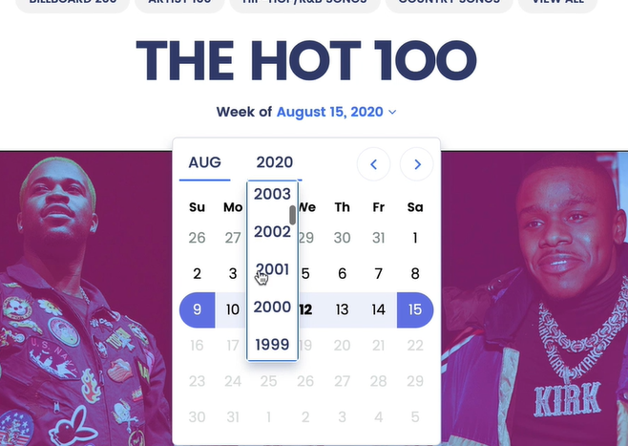

Scrape top 100 from a date and then get song title,

Make a Spotify play list using the spotify API to build the list

Step 1 - Scraping the Billboard Hot 100

1. Create a new project in PyCharm and create the main.py file.

2. Create an input() prompt that asks what year you would like to travel to in YYY-MM-DD format. e.g.

2. Using what you've learnt about BeautifulSoup, scrape the top 100 **song titles** on that date into a Python List.

Hint: Take a look at the URL of the chart on a historical date: <https://www.billboard.com/charts/hot-100/2000-08-12>

[SOLUTION](https://gist.github.com/angelabauer/0fb1ca02de8f96c79830e0184a1f405c)

Spotify

O auth

<https://developer.okta.com/blog/2017/06/21/what-the-heck-is-oauth>

<https://developer.spotify.com/documentation/general/guides/authorization-guide/>

Spotipy for auth

<https://pypi.org/project/spotipy/>

Spotify uses OAuth to allow third-party applications (e.g. our Python code) to access a Spotify user's account without giving them the username or password. We'll explore OAuth more in later modules on web development, but if you want you can read more about it here: <https://developer.okta.com/blog/2017/06/21/what-the-heck-is-oauth>

[Authenticating with Spotify](https://developer.spotify.com/documentation/general/guides/authorization-guide/) is quite complicated, especially when you want to access a user's account. So instead, we're going to use one of the most popular Python Spotify modules - [Spotipy](https://pypi.org/project/spotipy/" \t "_blank) to make things easier.

Now that you've come so far and completed 45 days of Python, you're going to approach this challenge like a real developer, figuring things out from the documentation.

4. Using the [Spotipy documentation](https://spotipy.readthedocs.io/" \t "_blank), figure out how to authenticate your Python project with Spotify using your unique Client ID/ Client Secret.

5. Use http://example.com as your Redirect URI. You're looking to get the currentuser id (your Spotify username). As per the documentation, make sure you set the redirect URI in the Spotify Dashboard as well.

HINT 1: You need your own Spotify app Client ID and Secret, the ones in the image above won't work.

HINT 2: This is the method you'll need: <https://spotipy.readthedocs.io/en/2.13.0/#spotipy.oauth2.SpotifyOAuth>

HINT 3: Try passing the Client ID and Secret directly into the **SpotifyOAuth()**constructor instead of using export or set.

HINT 4: You need the ["playlist-modify-private"](https://developer.spotify.com/documentation/general/guides/scopes/) scope in order to create a private playlist on Spotify.

HINT 5:  If successful, you should see the page below show up automatically (be sure to click Agree):

Step 3 - Search Spotify for the Songs from Step 1

1. Using the [Spotipy documentation](https://spotipy.readthedocs.io/" \t "_blank), create a list of Spotify [song URIs](https://spotipy.readthedocs.io/en/2.13.0/#ids-uris-and-urls) for the list of song names you found from step 1 (scraping billboard 100).

HINT 1: You can use the query format "track: {name} year: {YYYY}" to narrow down on a track name from a particular year.

HINT 2: Sometimes a song is not available in Spotify, you'll want to use exception handling to skip over those songs.

HINT 3: pprint() might help you visualise the result better. <https://docs.python.org/3/library/pprint.html>

[SOLUTION](https://gist.github.com/angelabauer/e6087a48f9d1a87d4ec15fc29830892b)

Fullscreen

Step 4 - Creating and Adding to Spotify Playlist

1. Using the [Spotipy documentation](https://spotipy.readthedocs.io/" \t "_blank), create a new private playlist with the name "YYYY-MM-DD Billboard 100", where the date is the date you inputted in step 1.

HINT: You'll need the user id you got from Step 2.

2. Add each of the songs found in Step 3 to the new playlist.

HINT: You'll need the playlist id which is returned as an output once you've successfully created a new playlist.

[SOLUTION](https://gist.github.com/TheMuellenator/c84616c21f0f9ce68c12c357d3e1c794)

[COMPLETED PROJECT](https://repl.it/@appbrewery/music-time-machine-end)